Recall: What is Oersted’s Principle? What is Ampere’s Force Law?

Electromagnet - any device that produces a magnetic field as a result of an electric current
What is a benefit of using an electrically powered magnet?

Coiled Conductors:
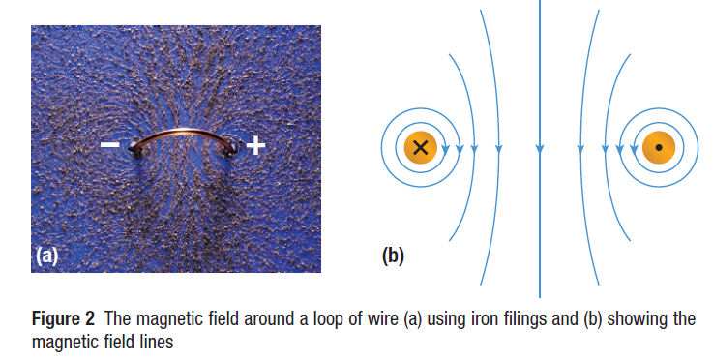

In the centre of the loop, the magnetic field points straight through. The positive and negative signs denote the direction of the conventional current from positive to negative.
___________________ - when the wire is wound into a coil containing several loops

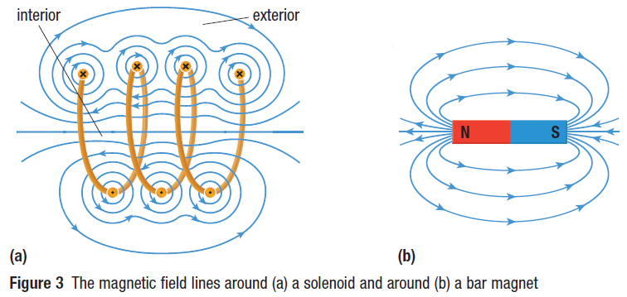
The magnetic field around a solenoid has a shape similar to that of a bar magnet.

Factors That Determine the Strength of an Electromagnet
Factor | Explanation | Equation
Current in the Coil | As current increases, field strength _________________
Number of turns in coil | The greater the number of coils, the _______________  the field strength.
Type of Material | The more ferromagnetic, the material within the coil, the _______________ the magnet’s strength

The most powerful electromagnets have several thousand loops of wire, work with large currents and have a soft iron core.
Example 1 Determine the change in strength of a magnetic field around a coil if the current in the conductor decreases from $3.6 A$ to $1.5 A$ while at the same time the number of turns in the coil is increased by $20\%$.

Right – Hand Rule for a Solenoid:
- The fingers of your right hand wrap around the coil in the direction of the conventional current, while your right thumb points in the direction of the north magnetic pole of the coil.
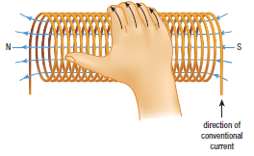
Example 2 For the coil shown, add in the battery schematic and show the direction of the current flow that would cause the labeled polarity.
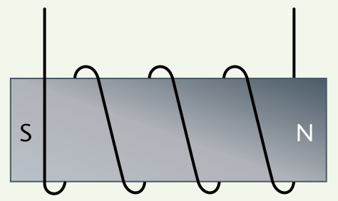

Uses of Solenoids
- A solenoid has many uses because it can operate like a bar magnet, but it can be switched on and off. This is called an electromagnet.
- So a solenoid can be used to turn things on and off, to pick up things and then to let go, or to cause motion and then reverse the motion.
- Solenoids are used in many devices such as audio speakers, electric bells, car starter motors.
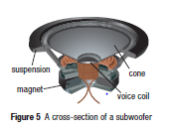
Subwoofers
- produces only low-frequency or deep bass
sounds that are created by longitudinal compressions and
rarefactions (opposite of compression) of air
- made up of a cone that is either plastic or paper that
quickly moves outward to cause a compression and inward
to cause a rarefaction
- A permanent circular magnet surrounds a solenoid. The solenoid is called a voice coil.
- The voice coil is connected to the cone.
- An amplifier directs the current through the voice coil which creates a magnetic field that attracts the voice coil to the magnet.
- This process repeats, producing compressions and rarefaction.

School Bells:
- School bells are designed to run continuously for as long as it is needed.
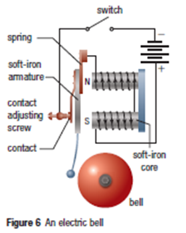
- When the switch is closed, current is directed at
the solenoids.
- The solenoids produce a magnetic field that is amplified
by the soft iron cores.
- The soft iron armature is attracted to the core and the
bell rings once.
- Now the armature pulls away from the contact, so the
circuit is interrupted.
Since the armature is on a spring, it springs back and
makes contact, completing the circuit once more.
- The process repeats until the switch is opened.
The Motor Principle
Moving Conductors with Electricity
When English physicist Michael Faraday saw that an electric current in a wire caused a compass needle to move, he wanted to see if the ________________ would be true. Could a magnetic field cause a current carrying conductor to move?
Not only did he succeed in showing this, in 1821 he made the first _______________________.
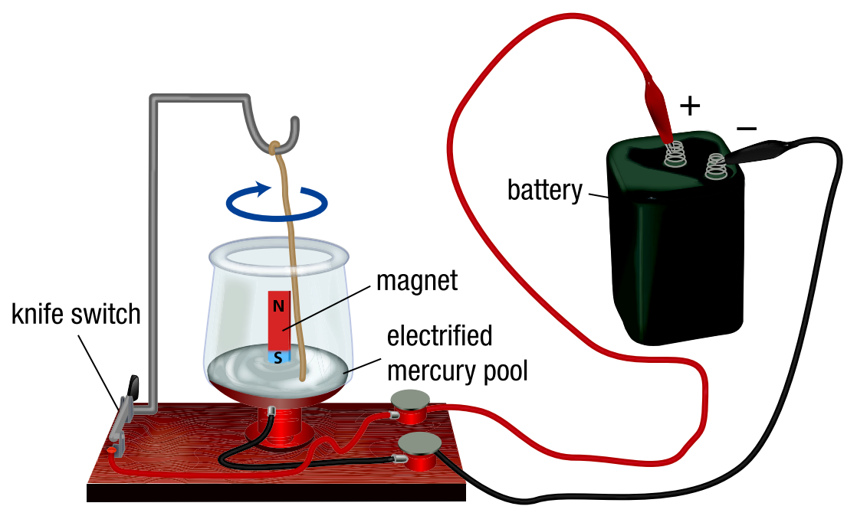

The copper wire in Faraday's motor design moved because the magnetic field in the copper wire interacted with the magnetic field of the permanent bar magnet.
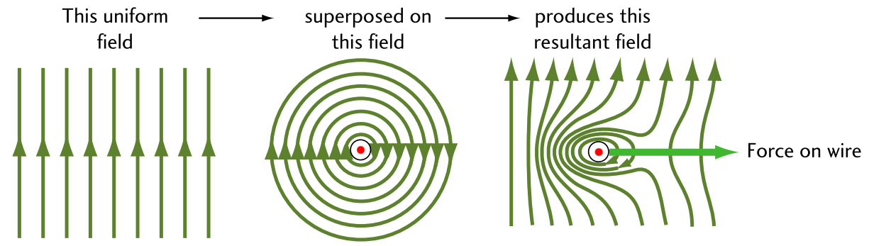

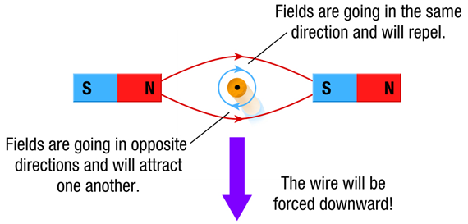
The movement of a current carrying conductor in an external magnetic field is described by the motor principle. This states that a current carrying conductor that cuts across external magnetic field lines experiences a force perpendicular to both the magnetic field and the direction of the electric current.
The magnitude of the force depends on both the external field and the current and the angle between the conductor and the magnetic field.
$F_{M}=BILsinθ$, where
$B$ stands for $L$ stands for
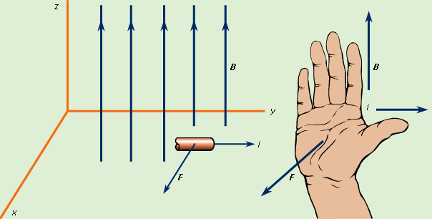
$I$ stands for $θ$ stands for

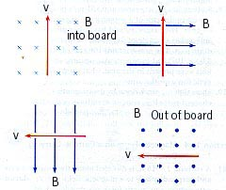
Practice:

Electric motor
A device that uses an electromagnet in a permanent magnetic field to apply a directed force is called an electric motor .
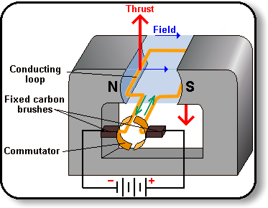
It operates by the motor principle (aka RHR#3).
The electric motor directs electric force full circle, without stopping
part way.
In a DC motor, the electromagnet has to change its polarity once every
rotation. This polarity change is made because a split ring commutator
reverses the current flow in the rotating armature.
A DC Motor

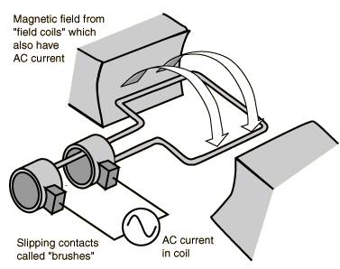
The Simple Induction AC Motor
The direction of AC alternates back and forth anyway. (In North America,
this cycles 60 times per second . . . which translates to rps of the motor.)
An AC Motor

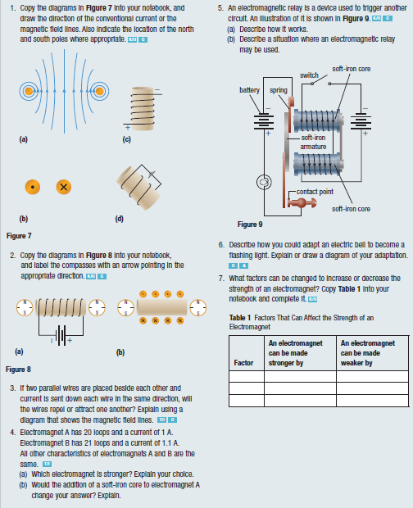

Homework: pg. 589 #2 pg. 599 #9 – 11, 13, 22, 23, 24
Read Section 17.4 pg. 595 #1, 2 pg. 601 #26 – 30

