Electrical Resistance

- Georg Simon Ohm (1789 – 1854) noticed that for a substance, the ratio of the voltage drop through it compared to the current flowing through it was a constant. He called this ratio resistance.

- Even though most materials can be classified as _________________ or _________________, some conductors allow charges to move through them more easily than others.

- The opposition to the motion of charge (current flow) in a conductor is the conductor’s ____________________.

Where the S.I. unit for resistance
is _________________

Four Main Factors That Determine the Resistance
Factor | Explanation | Relationship | Equation
Type of Material | Some materials are easier to flow through than others
Length of Material | Traveling longer distance requires more energy
Cross-Sectional Area | Larger traveling space means more charges can flow
Temperature | Charges are moving through atoms; higher temperature mean atoms move more

Example 1 The resistance of a curling iron is $19.0$ . What is the current in the iron when it is plugged into a $120 V$ outlet?

Example 2 A toaster uses a strip of metal $15.0 cm$ long as a heating element. Initially, it has a resistance of $2500$ .

- What current will it draw when plugged into a $120 V$ source?

- What happens to the current it draws as time progresses? Justify your answer.

Example 3 A piece of metal, $20.0 cm$ long, $2.50 cm^{2}$ cross-sectional area is used as a heating element.

- When plugged into a wall socket at $120 V$ it draws $3.50 A$ of current. What is it’s resistance?

- If the element is plugged into a wall socket in Europe ($240 V$), what current will it draw?

- The wire is now stretched and cut so that it is $15.0 cm$ long and $1.00 cm^{2}$ in area. What is it’s new resistance?
Electrical Power

Recall: Power is the rate at which ____________ is done and work is the change in ________________.

- Power can also be expressed
in terms of ____________ and ____________:

- But, using Ohm’s Law _________________, electric power can be expressed in the following alternate forms:

- The SI unit of power is the watt (____) which is a (_______).

Example 1 Find the resistance of a $1320 W$ space heater which is plugged into a $120 V$ outlet.

Example 2 A $60 W$ bulb is plugged into a $120 V$ plug. What current does it draw?
Kirchoff’s Laws and Resistors in Circuits

Resistors in Series

- When resistors (loads) are connected one after another in series, there is only ___________________ for the current to follow.

Note: If one load burns out, the whole circuit goes out.

Kirchhoff’s Laws for a series circuit state that:

- The equivalent resistance in a series circuit (total resistance) is the ________ of the individual resistances:

- The current in each resistor is the ____________ and is also equal to the _______________ current flowing in the circuit:

- The sum of the _____________ across each of the individual loads will equal the ______________________________________.

Note: Ohm’s Law can also be applied to the total quantities.

Example 1 Find $R_{T}$ and $I_{T}$ for the following circuit:
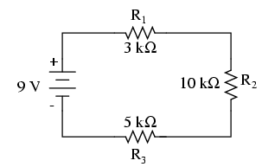

Resistors in Parallel

- When resistors (loads) are connected one after another in parallel, there is ____________________________ for the current to follow.

Note: If one load burns out, the others will keep on working.

Kirchhoff’s Laws for a parallel circuit state that:

- The reciprocal of the equivalent resistance in a parallel circuit (total resistance) is the ________ of the reciprocal of the individual resistances:

Note: The total resistance will always be __________ than any of the individual branch resistances.

- The total current in the circuit is the _________ of all the individual branch currents. Or the total current into a junction point is equal to the total current out of a junction point.

- The voltage across each of the individual branches will be the ___________.

Note: Ohm’s Law of ______________ still applies to the total quantities.

Example 2 Find $R_{T}$ and $I_{T}$ for the following circuit:

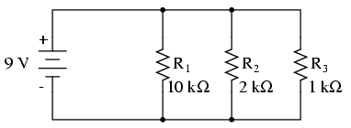

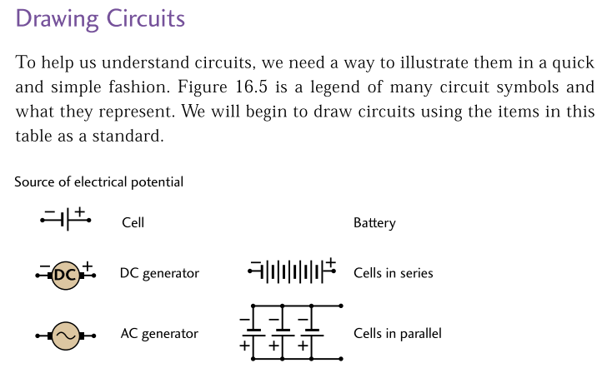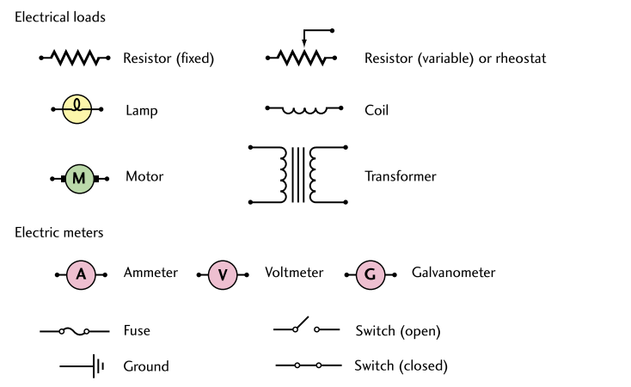

Homework: pg. 575 #7, 8, 21 – 28 Read 16.6 pg. 563 #1 – 3 pg. 575 #5, 29 – 34

