The Earth’s climate is not static and goes through natural cyclic changes (ex: Ice Age 20000 years ago)

Changes in climate are triggered by changes in Earth’s energy balance (ie: if the Sun’s energy is absorbed differently, climate changes)

Long Term Changes in Climate

Continental Drift -

As mountain ranges form, _________________ climates change.

What is the difference in climate between regions with large bodies of water, and those regions without large bodies of water?

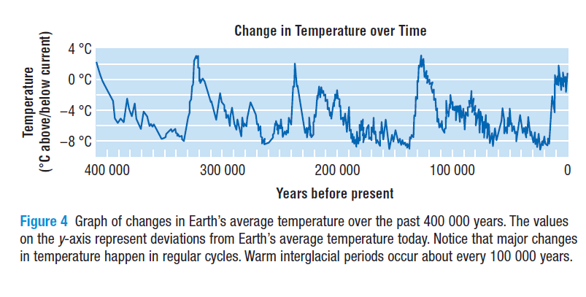
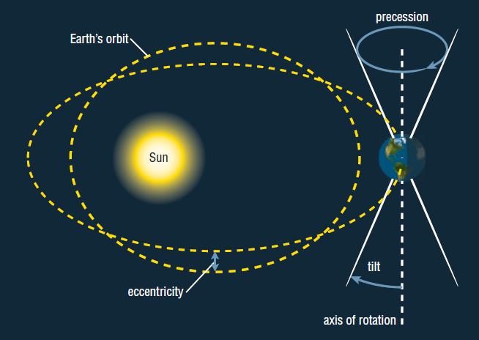
Using the picture to the right, explain how eccentricity, precession and tilt contribute to interglacial and glacial periods.

Albedo - a measure of how much of the Sun’s radiation is reflected by a surface. (related to percent of radiation reflected)

  - ice and snow have high albedo (therefore it’s ____________)

  - grass and trees have a low albedo (therefore it’s ____________)

Albedo Effect - an increase in the Earth’s temperature causes ice to melt, so more radiation is absorbed by Earth’s surface, leading to further increases in temperature.

This is a _________________ feedback loop.

Short Term Changes in Climate

In terms of climate, what is considered a short period of time? ___________________

How can volcanos affect climate short term?

What is El Nino?

Ways that we can study climate change

Proxy records - Stores of information in tree rings, ice cores, and fossils that can be measured to give clues to what the climate was like in the past

- ________________ - Ice has tiny air bubbles that have been trapped for thousands of centuries and can be tested for various gases

- _________________ - The thickness of a tree ring indicates the growing conditions

-How can you tell if the year was warm and wet or cold and dry?

- _________________ - Corals have layers of growth each season and give clues about the temperature of the ocean

- ______________ and fossils – How do these give us clues about the climate?

