- Complete each incomplete sentence and draw the characteristic ray it describes.
Convex Mirror Characteristic Rays
Parabolic Characteristics:
Any incident ray parallel to the principal axis will | 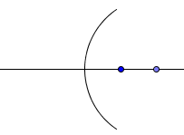
Any incident ray passing through the Focus will
Circular Characteristics:
Any incident ray passing through the Centre of Curvature will

Any incident ray striking the Vertex will

NOTE: Any ray originating on the object, and reflecting off the mirror, will appear to have come from a corresponding point on the image. Characteristic rays simply help predict image characteristics.

Convex Mirrors | Image Characteristics
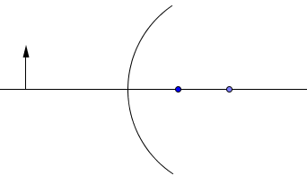 | Size  Inversion  Location  Type
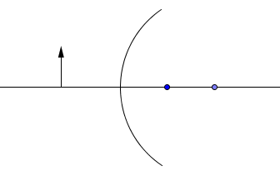 | Size  Inversion  Location  Type
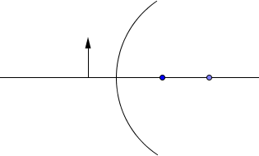 | Size  Inversion  Location  Type

Complete the following Statements:
- In order to produce a VIRTUAL IMAGE with CONVEX MIRROR, an object must be placed

- In order to produce the LARGEST IMAGE POSSIBLE with CONVEX MIRROR, an object must be placed

- In order to produce an IMAGE SMALLER THAN THE OBJECT with CONVEX MIRROR, an object must be placed

- If the OBJECT IS MOVED far away from a CONVEX MIRROR, the image will move

