Weather versus Climate:

- Weather:
  - ____________________ conditions, including temperature, precipitation, wind and humidity, in a particular location over a ___________ period of time
  - We describe weather using terms like:
- Climate:
  - The usual pattern (the ____________) of the weather in a region over a ______________ period of time (usually 30 years)
  - The climate of a region determines the types of ______________ and ________________ that live there

Factors Affecting Climate:
- Distance from ______________ (latitude)
- Presence of large bodies of _______________
- Presence of ____________ and ____________ currents
- Land formations
- Height above sea level (________________)

Sun & Earth's Climate System:
Climate System
  - The complex set of components that interact with each other to produce Earth’s climate
  - These components include:
    - _____________________ – (gases surrounding earth)
    - _____________________ – (liquid water, ice, water vapour)
    - _____________________ -- (Earth’s rock crust, land surfaces)
    - _____________________ – (plants, animals, microbes etc.)
  - The climate system is powered by the SUN
  - The energy that Earth receives from the sun interacts with the components of the climate system to produce ________________ ___________

Earth Absorbs Energy from the Sun:
When radiation contacts a particle of matter, one of three things happens:
- 1. The radiation may be _______________________ by the particle, causing the particle to gain energy
- 2. The radiation may be ______________________ through the particle
- 3. The radiation may be ____________________ off the particle

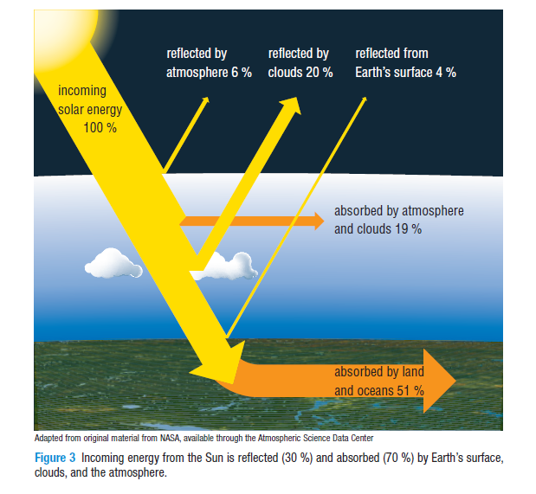

- If 70% of solar energy that reaches Earth is absorbed, why doesn’t the Earth just heat up tremendously?

- Since the Sun is constantly shining on the Earth and the Earth is constantly absorbing its energy, why does the Earth’s average temperature remain relatively constant?

Earth's Surface Emits Energy:
- As the surface of the Earth warms up from the Sun’s energy, it gains _________________ energy and then converts it to ________________ __________________ (IR) radiation
- The amount of energy _________________ by Earth’s system is equal to the amount of energy Earth’s system ____________________ from the Sun
- Because of this balance of energy, Earth’s global temperature stays _____________ ____________.
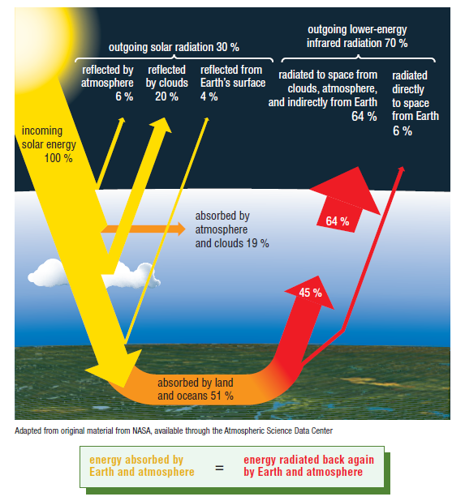

Equilibrium:

- The balance between energy ________________ from the Sun and energy _________________ from Earth ensures that Earth’s global temperature remains fairly constant

- Without a climate system, the Earth would still reach an energy ___________________, however, Earth would be much _________________.

- The Greenhouse Effect contributes to the Earth not being so cold. Without the climate system’s greenhouse effect, the Earth’s average global temperature would be -18ºC instead of 15ºC

Latitude & Climate Zones:
- The energy from the Sun is ____________ __________________ near the Earth’s equator since it hits Earth’s surface directly.

- Energy from the Sun is _________ ____________________ near the two poles since energy hits Earth’s surface at an angle and spreads over a larger area

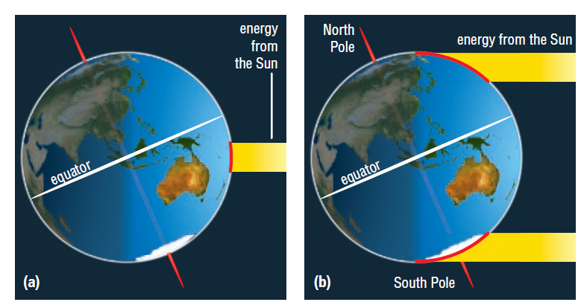

Homework:
- Read Section 8.1 (pg. 319-321) Do questions #1, 4
- Read Section 8.3 (pg:325-329) Do question #2, 3, 5
- Read Section 8.4 (pg. 330-335) Do question #1, 4, 5

