Recall: What is the Motor Principle? What are Kirchoff’s and Ohm’s Laws?

AC vs. DC Current
Alternating Current (AC) | Direct Current (DC)

We know that a current produces a magnetic field. Can a magnetic field produce an electric current?

Lenz’s Law:
- If a changing magnetic field induces a current in a coil, the electric current is in such a direction that its own magnetic field opposes the change that produced it.

- The induced current (called Eddy currents) will always ________________ the change in the magnetic field.
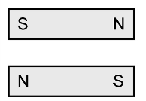
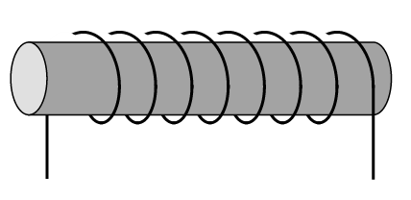

Transformers
Transformers are electrical devices that use two solenoids to change the ______________ of AC current.
A transformer that increases the voltage is called a ____________________ transformer and one that
decreases the voltage is called a ________________________ transformer
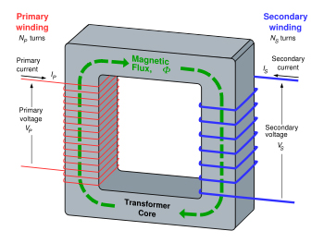
- An AC current is sent into the primary
Coil

- The current creates a changing
magnetic field (magnet in the core)

- The magnetic field induces a current in
the secondary coil

Why have a metal core?
We know that the first coil will produce a magnetic field everywhere. The metal core “focuses” the magnetic field into the second core (called magnetic flux, ${}_{B}$).
- The core is usually made of laminated iron
-Laminated means split into layers (non-metal layers in between) 
- Properly designed transformers are between 90% and 99% efficient (< 10% power loss)
Voltage Change
Call the voltage across the first coil $V_{1}$ and the number of turns in it $N_{1}$. Similarly for the second coil, $V_{2}$, $N_{2}$
Each turn in the coil creates a magnetic flux, ${}_{B}$, in the iron core. The total flux is transferred to the secondary coil (assume ideal conditions):
$\frac{V_{1}}{N_{1}}=\frac{{}_{B}}{dt}$ and $\frac{V_{2}}{N_{2}}=\frac{{}_{B}}{dt}$
Therefore, $\frac{V_{1}}{N_{1}}=\frac{V_{2}}{N_{2}}$
Or $V_{2}$ $=\frac{N_{2}}{N_{1}}$ $V_{1}$

Example 1 A transformer is created with 60 coils in its primary coil and 10 in its secondary coil.
- Is it a step-up or step-down transformer?

- If $1200 V$ are put into the primary coil, what voltage is induced in the secondary coil?

Example 2 Consider a transformer with 1200 turns in its primary coil and with a supply voltage of 22 kV.
- If it is designed to supply a voltage of 120 V for your house, how many turns will it need?

- Is it a step-up or step-down transformer?

What is the purpose of transformers?
The higher the voltage in the power lines, the ____________ the power loss (and hence cost).

Recall that $P=I^{2}R=$ $\frac{V^{2}}{R}$

The difference is actually a squared relationship! For example, the loss in sending $20 MW$ of power $1 km$ costs about $\$36$ at $230 kV$ or about $\$4100$ at $22 kV$!

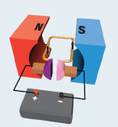
Electric Motors and Generators

Motors turn electrical energy into motion and generators turn motion into electrical energy.

Both use the same setup as shown to the right.

Electric Motors (DC motor shown below)

Recall that a current travelling in a constant magnetic field experiences a force on it.

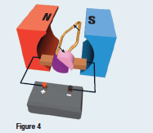
By passing a current through a loop of wire in a magnetic field, a force is created causing the wire to twist.

- Using the right hand rule for motor principle, we see that the
force is __________________ at the left of the loop and

__________________ at the right.
The wire loop has rotated to the split. The circuit is now open,
there is no current and no more magnetic fields are being produced
by the loop of the wire. The loop continues to spin because of
_______________.

Electric Generators
Generators work on 2 basic principles:
Faraday’s Law of Electromagnetic Induction
- a magnetic field that is moving or changing intensity near a conductor causes (or
induces) electron flow in the conductor

Lenz’s Law
- the direction of the induced current creates an induced magnetic field that
___________ the motion of the inducing magnetic field.

Generators are a little more complicated than motors. The charges move relative to the magnetic field and hence experience a force.
It works like a motor in ____________________.

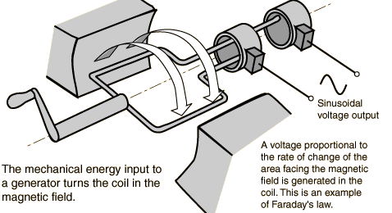

Homework: Read Sections 18.1-18.4  pg. 625 #4, 5, 9, 10, 20

