frog dissection NAME __________________________
Objectives:
• Describe the appearance of various organs found in the frog.
• Name locate and identify the organs that make up various systems of the frog.
• Compare and contrast frog anatomy to our past dissections.
• Contrast and compare various frog's organs to human.
Materials:
Safety goggles, dissecting pins, gloves, forceps, lab apron, scissors, paper towel, dissecting probe, preserved frog, hand lens, dissection tray.
Purpose:
In this lab, you will dissect an frog in order to observe the external and internal structures of frog anatomy
BACKGROUND INFORMATION:
Frogs are classified as amphibians "live a double life". Frogs are part of the amphibian order, Anura. Tadpoles are aquatic and herbivores. Adult frogs can live on land and in water and are carnivores. Strong muscles and special fused bones help frogs be powerful swimmers and jumpers. Frogs have loose, mucous lined skin to help them escape from predators, and keep them wet which aides in cutaneous respiration (breathing through the skin). Tadpoles breath through gills. Frogs breath though underdeveloped lungs and their skin. Cutaneous respiration limits the frogs body size. The backs of frogs are dark, while their undersides are light, to camouflage them on land and water. Frog brains are smaller and less developed than other vertebrates, they also have a 3 chambered heart.
SEXING YOUR FROG:
Place a frog on a dissection tray. To determine the frog’s sex, look at the hand digits, or fingers, on its forelegs. A male frog usually has thick pads on its "thumbs," which is one external difference between the sexes, as shown in the diagram below. Male frogs are also usually smaller than female frogs. Observe several frogs to see the difference between males and females.
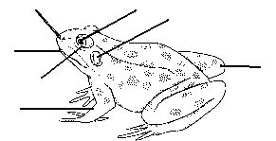
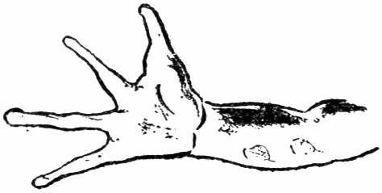

PROCEDURE AND OBSERVATIONS: EXTERNAL ANATOMY
1. Place the frog on its belly (ventral side) in the dissecting an.
2. Examine the hind legs and front legs of the frog. The hind legs are strong and muscular and are used for jumping and swimming. The forelegs provide balance and cushion the frog when it lands after jumping. Notice the difference between the toes of the hind legs and those of the front legs. How many toes are on the front legs_______________. How many are on the hind legs__________________________. Label the hind and front legs.
3. Locate the large, bulging eyes. The frog has 3 eyelids. The 2 outer ones are the color of the fog's body. They do not move. Locate the third eyelid. It is a transparent membrane the protects the eye while permitting the frog to see under water. It is call a nictitating membrane. Label the eye and the nictitating membrane.
4. Behind each eye find the circular eardrum called a tympanum. They locate the two openings into the nasal cavity. The nasal openings, are also call external nares, found toward the tip of the snout will closes when the frog is under water. Label the mouth, tympanum, and the external nares.
5. Feel the frog's skin. It is smooth, moist and thin. The frog can breathe directly through its skin as well as with its lungs. Turn the frog onto its ventral side and notice the color difference. Why does each sides color help protect the frog from predators?_______________________________________________________
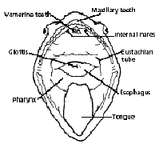

INTERNAL MOUTH STRUCTURES
6. Place the frog on its dorsal side in the dissecting pan and cut the corners of the mouth . CAUTION: Be careful when using scissors.
7. Locate the TONGUE. Is it attached to the front or the back of the mouth?________________________ In a live frog, the tongue is sticky and is used to catch insects. Pull on the tongue. Notice that it is still flexible.
8. Feel the inside of the upper jaw ( maxilla) and the lower jaw (mandible). The teeth you feel are the MAXILLARY TEETH. Locate the 2 VOMERINE TEETH on the upper jaw. They are located toward the front of the upper jaw and between the internal nares ( internal nostril openings). What are the maxillary teeth and vomerine teeth used for?________________________________________________________
9. Push carefully on the eyes observe how they fill a space in the mouth. The eyes help hold the prey as a frog is swallowing it.
10. Locate a vertical opening toward the back of the mouth. This is the GLOTTIS. It is the opening to the trachea (windpipe) that leads to the lungs.
11. Find the GULLET (throat) it leads to the opening of the esophagus. On both sides of the gullet, near the cut jaws are opening to the EUSTACHIAN TUBES. Use your probe. Where does the eustachian tube lead? ______________
What is its purpose?___________________________________________________
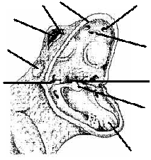
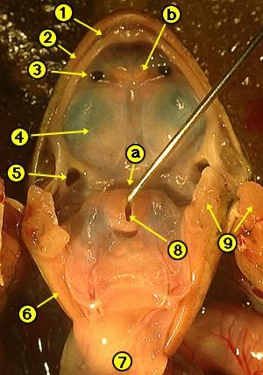
LOCATE and label THE FOLLOWING
1. Vomarine Teeth: Used for holding prey
2. Internal Nares (nostrils) breathing
3. Eustachian Tubes: equalize pressure in inner ear
4. Glottis : Tube leading to the lungs
5. Gullet: Opening leading to the esophagus
6.Tongue: Front attached, aids in grabbing prey
7. Tympanic Membrane: eardrum, located behind eyes
8. Nictitating Membrane: clear eyelid, protects the eye
9. Maxillary Teeth: Used for holding prey
10. Eye: vision

FILL IN THE DATA TABLE
ORGAN | FUNCTION | SYSTEM
- nictitating membrane

- tympanum

- NOSTRIL

- vomerine teeth

5.eustachian tubes

- glottis

- GULLET

- EYE

9.MAXILLARY TEETH

10. INTERNAL NARES

DISSECTING THE FROG
1. Place the frog on its dorsal side and secure it in place with dissecting pins through each of the legs.
2. With your scissors make a cut (through the skin only) along the midline of the belly from the pelvis to the throat.
3. Now make transverse cuts through the skin below each of the fore limbs and above each of the hind legs. If needed you may pin the skin back. Notice the blood vessels under the skin. Why are there so many?____________________________________________
4. Notice the abdominal muscles. Now cut through the muscle layer and repeat the incisions you mad in step 2 and 3. BE CAREFUL NOT TO CUT TO DEEP AND DAMAGE THE UNDERLYING ORGANS.
5. You will have to cut through the sternum (breastbone). Open and re-pin the frog.
6. If your frog is female, the body cavity maybe full of black eggs. You may have to remove one side in order to continue your dissection.

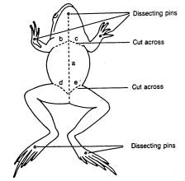

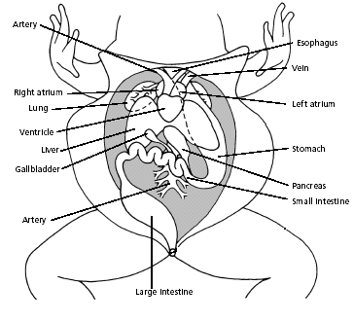
INTERNAL ANATOMY:
The digestive system consists of the organs of the digestive tract and the digestive glands. Swallowed food moves from the mouth down the esophagus and into the stomach and then into the small intestine. Bile is a digestive juice made by the liver and stored in the gall bladder. Bile flows into a tube called the bile duct. Digestive enzymes from the pancreas flows into this duct. Both bile and pancreatic enzymes flow into the small intestine. Most digestion and absorption of food into the bloodstream takes place in the small intestine. Indigestible materials pass through the large intestine and then into the cloaca, the common exit chamber of the digestive, excretory, and reproductive systems.

1.Stomach: First site of chemical digestion, breaks down food
2. Liver: Makes bile (aids in digestion)
3. Gall bladder: Stores bile
4. Esophagus: Tube that leads to the stomach
5. Pancreas: Makes insulin (aids in digestion)
6.Small Intestine (duodenum and ileum): absorb nutrients from food
7. Mesentery: Holds coils of the small intestine together
8. Large Intestine: Collects waste, absorbs water
9. Spleen: Part of circulatory system, stores blood
10. Cloaca: Where sperm, eggs, urine, and feces exit.
11. Artery; take blood away from the heart
12. Vein: take blood toward the heart
13. left atrium pumps blood into the ventricle
14. Right atrium pumps blood into the ventricle
15. Lung: organ for oxygen and carbon dioxide exchange

1. Locate and label the largest organ in the abdominal cavity it is the reddish brown LIVER. How many lobes does the liver have __________________?
2. Locate the greenish sac attached to the liver. This is the GALL BLADDER. What is stored in the gall bladder?________________________ What does bile digest?____________________________
3. Beneath and to the right of the liver is a j shaped STOMACH. With your scissors open the J of the stomach to observe what the frog may have eaten. Was there anything in the stomach? _____________ What do you think the frog ate._____________________. Notice the ridges inside the stomach these muscle are call rugae. They help mix the food with stomach acid into a mixture called chyme. When you are hungry they rub together and your stomach make a rumbling noise. A pyloric sphincter valve regulates the exit of digested food from the stomach to the small intestine.
4. The stomach attaches to the small intestine. The straight part of the small intestine is called the DUODENUM and the coiled section is the ILEUM. The coils of the ileum are connected by thin transparent membranes with blood vessels. This tissue is call MESENTERY. Mesentery helps keep your intestine from knotting up. After cutting the small intestine away from the large intestine, measure how long your small intestine is in cm ____________________cm.
Name the two sections of the small intestine _______________________ and _____________________.
5. The small intestine widens to form the LARGE INTESTINE. The large intestine is a straight tube leading to the anus. The lower portion of the large intestine is called the cloaca. Waste, urine and sex cells are expelled here.
6. In the mesentery along the inner curve of the stomach locate the pinkish pancreas. In the mesentery find a reddish spherical structure call the spleen. The spleen filters out worn out red blood cells and platelets from the blood.
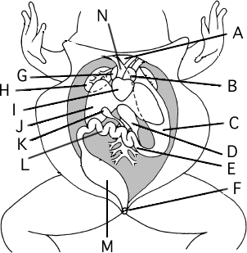

LABEL:
1. LIVER
2. GALL BLADDER
3. STOMACH
4. SMALL INTESTINE (ileum, duodenum) two letters
5. CLOACA
6. MESENTERY draw in label
7. PANCREAS
8. LARGE INTESTINE
9. SPLEEN draw in label
10. HEART b,g,i
11.LEFT ATRIUM,
12. RIGHT ATRIUM,
13. VENTRICLE
14. ESOPHAGUS
15.LUNG
16. ARTERY
7. The respiratory system consists of the nostrils, trachea and bronchi which opens into two lungs. The walls of the lungs are filled with which are microscopic blood vessels through which gasses diffuse in and out of the blood. Locate the lungs, 2 reddish brown saclike structures. Insert a medicine dropper down the frog's glottis and gently inflate the lungs. LABEL THE LUNGS
8. The circulatory system consists of the heart, blood vessels, and blood. The heart has two receiving chambers, or atria (singular: atrium), and one sending chamber, or ventricle. Blood is carried to the heart in vessels called veins. Veins from different parts of the body enter the right and left atria. Blood from both atria goes into the ventricle and then is pumped into the arteries, which are blood vessels that carry blood away from the heart. The heart is located between the lungs. Compare the thickness of the atria and the ventricle. Why is the ventricle so much thicker than the atria ________________________________
FILL IN THE DATA TABLE
ORGAN |  | FUNCTION | SYSTEM
- ESOPHAGUS

- STOMACH

- RUGAE

4. CHYME
5. SMALL INTESTINE
6. LIVER
7. LARGE INTESTINE
8. CLOACA
9. SPLEEN
10. PANCREAS
11. GALL BLADDER
12. LUNGS
 | 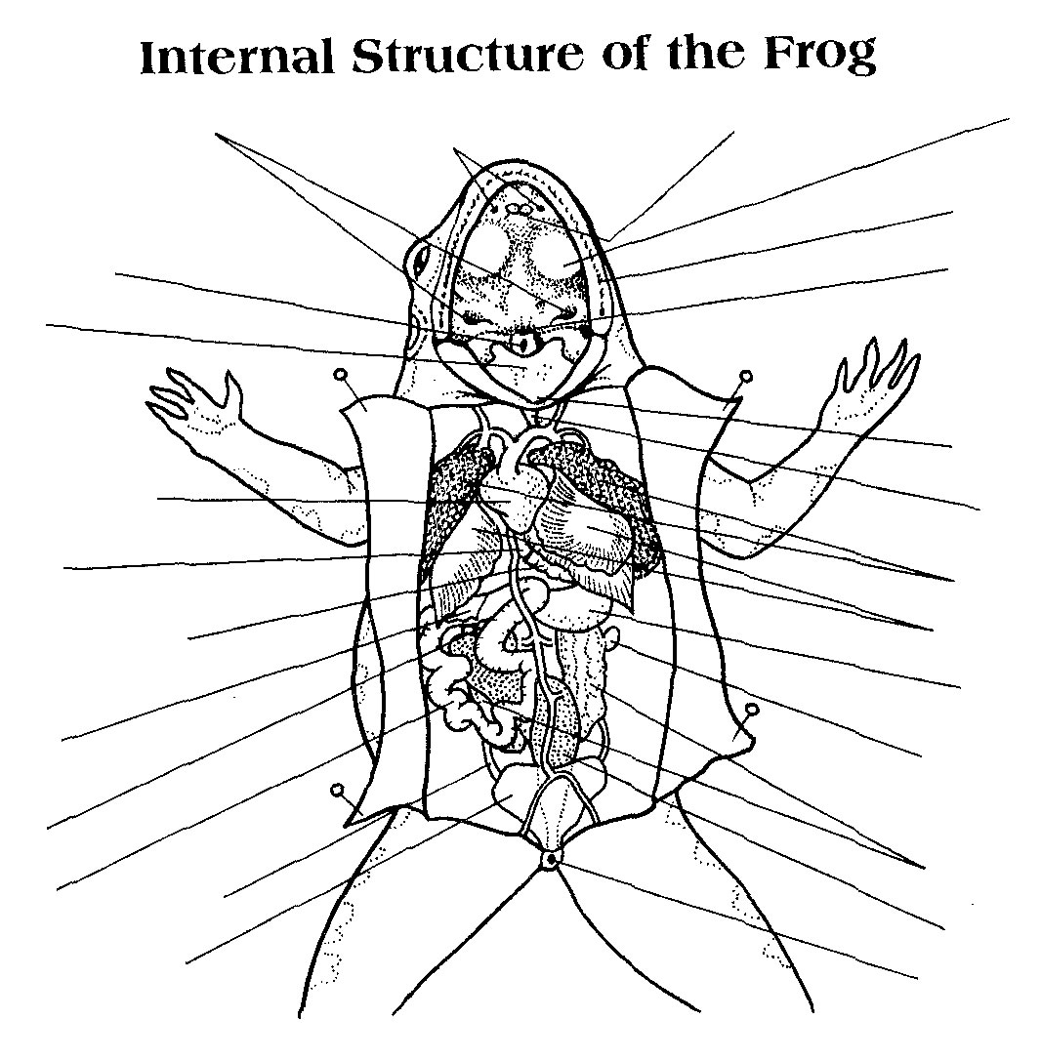

Extra Credit Study and Removal of the Frog's Brain
Turn the frog dorsal side up. Cut away the skin and flesh on the head from the nose to the base of the skull. Cut and scrape the top of the skull until the bone is thin and flexible. Be sure to scrape AWAY from you. Insert the scissors horizontally just below the cranium and above the eyes carefully chip away the roof of the skull to expose the brain. Cut away the heavier bone along the sides of the brain. Carefully remove the thin, gray membrane covering the brain. Find the nasal pits at the anterior end of the brain by the nostrils. The olfactory nerves leave these structures and connect to the most anterior lobes of the brain, the olfactory lobes (A)
Just posterior to the olfactory lobes is the cerebrum (B), and it is the frog's thinking center. The cerebrum helps the frog respond to its environment. Posterior to the cerebrum are the optic lobes (C), which function in vision. The ridge just behind the optic lobes is the cerebellum (D), it is used to coordinate the frog¹s muscles and maintain balance. Posterior to the cerebellum is the medulla oblongata (E) this is the which connects the brain to the spinal cord (F).
To receive extra credit for exposing the brain. You must first present a completed the data table and have all the brain parts labelled then show the brain dissection. the cleaner the dissection the better.
Complete the data table and label the brain.
Brain Part | Function | Letter
Cerebellum
Cerebrum
Olfactory Lobe
Optic Lobe
Medulla Oblongata

