Enzymes

What are Enzymes?
What are Catalysts?
What do Enzymes do?
2H₂O₂ → O₂ + 2H₂O
catalase

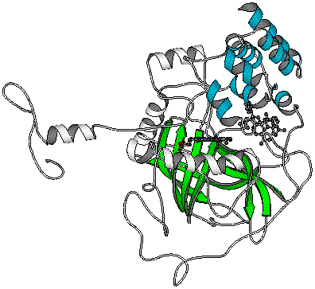
catalase
There are literally thousands of different enzymes which catalyze every major chemical reaction in the cells and bodies of living things.
In order for a reaction to proceed, particles must collide with sufficient energy. If molecules collide with insufficient energy, they will remain unchanged. The minimum amount of energy required for a given reaction to occur is called the activation energy. Every reaction has its own unique activation energy. Enzymes LOWER THE ACTIVATION ENERGY required for a reaction to proceed. This means that reactions are MUCH more likely to take place and thus can occur more often. Overall, this speeds up the desired chemical reaction. Not only that, but since enzymes are merely catalysts, each enzyme molecule can be reused!
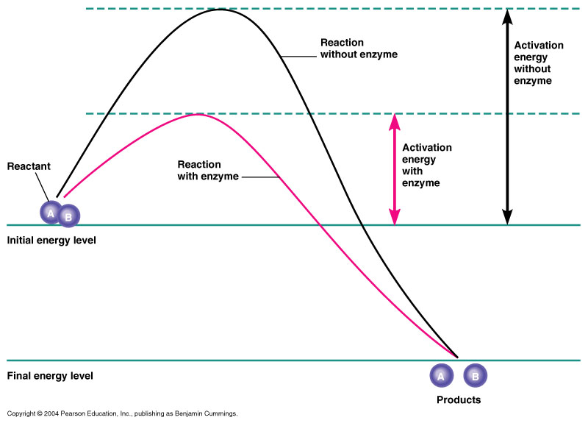
Wow! Enzymes make a world of difference. That’s millions of times faster!

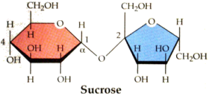

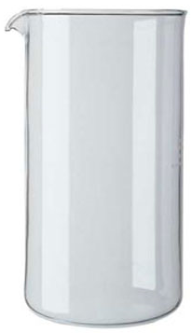
Water
+
Sucrase
Complete hydrolysis
in seconds
Years without any sign of hydrolysis
Water

Enzymes carry out many different types of biochemical reactions and are thus categorized
according to their function.

Type of Enzyme | Action
1. Hydrolases and hydrases | Add or remove water
2. Oxidoreductases | redox reactions (reactions involving a transfer of electrons)
3. Transferases | Split or form a C – C bond
4. Isomerases | Change the geometry or structure of a molecule
5. Ligases | Join molecules together using energy from ATP
6. Lyases | Add or remove groups to or from a C=C double bond

Terminology
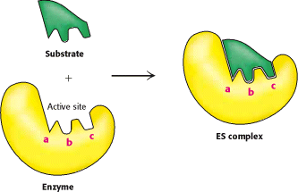

Enzymes are Specific

The 3D shape of an enzyme determines its function. Each enzyme can only catalyze ONE particular reaction or ONE type of reaction. In this way, enzymes can also be classified according to their level of specificity.

Enzyme Specificity | Action
Absolute
Group
Linkage
Stereochemical

How do Enzymes Lower Activation Energy?

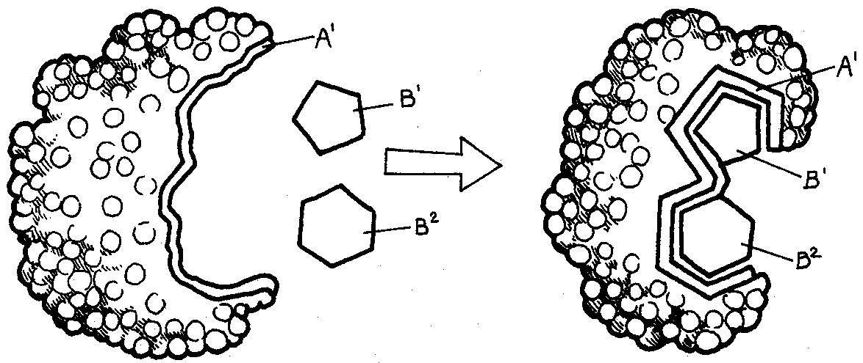

Induced-fit model
When a substrate enters the active site, it binds to the enzyme through a number of weak intermolecular bonds. The enzyme itself slightly changes shape to envelop the substrate.

This change of shape can line up substrate molecules and/or stress chemical bonds.
The activation energy of a reaction can be lowered in several ways:
- ______________________________________________________
- ____________________________________________________________________________________________________________
- ____________________________________________________________________________________________________________
The Catalytic Cycle
Since enzymes are not used up themselves in a chemical reaction they are reusable.

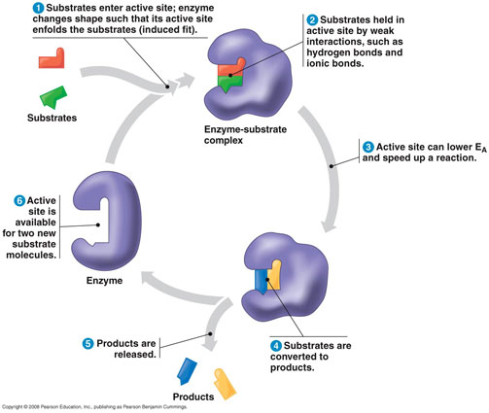
Enzyme Activity

Enzyme activity is influenced by ____________________________ and _______:
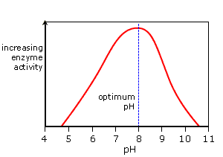
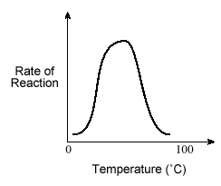
Most human enzymes function best between ________________. Below this range and they lose _____________________. Above this range the bonds become too __________.

Each enzyme works best at a specific ______. The bonds that hold peptides together are sensitive to hydrogen ion concentration. Most enzymes function best within a pH range of ___________.

Enzyme Inhibition and Allosteric Regulation

Inhibitors prevent substrates from entering the active site of an enzyme.
This renders the enzyme inactive.

There are two main kinds of inhibitors:
(1) Competitive (2) Non- Competative (allosteric)

- Competative:
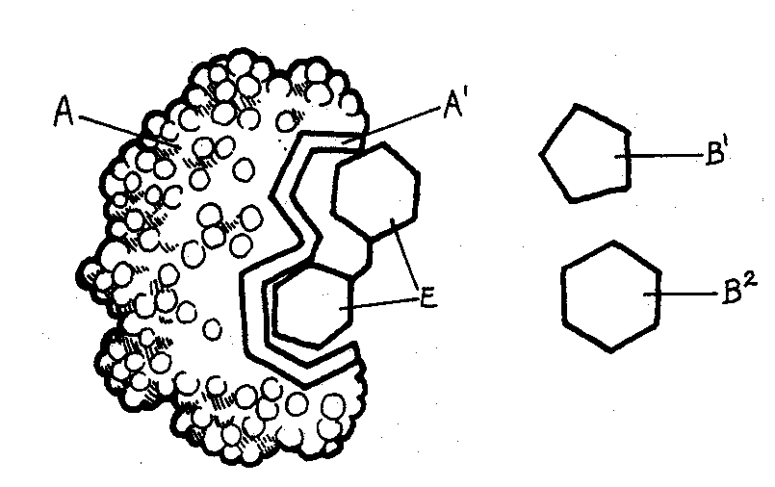
- Non-competative:
An inhibitor binds to the allosteric site , altering enzyme’s 3D shape!

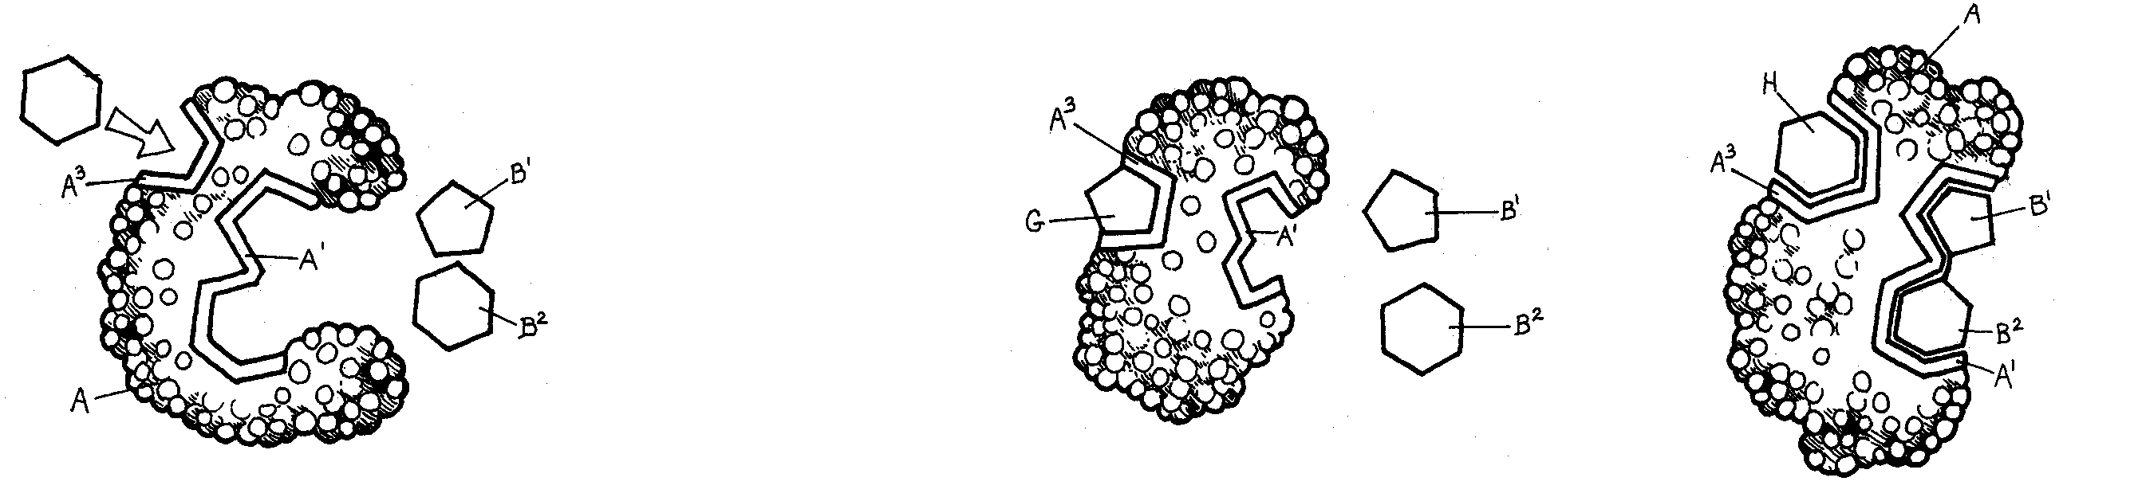
The allosteric site may instead be used
for positive regulation if the substrate
can only bind if an “activator” is present.
Inhibition Summary:
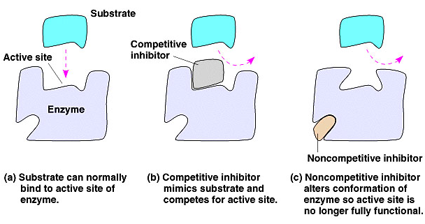
Feedback Inhibition (Negative Feedback)
Commonly the end product of a metabolic pathway acts as a non-competitive inhibitor for an earlier step in the pathway. This is an effective way to stop the synthesis of that product when adequate levels are produced in cells.

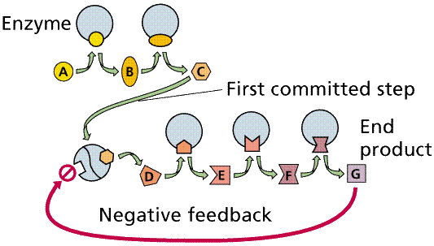

Cofactors and Coenzymes: Non-Protein Helpers

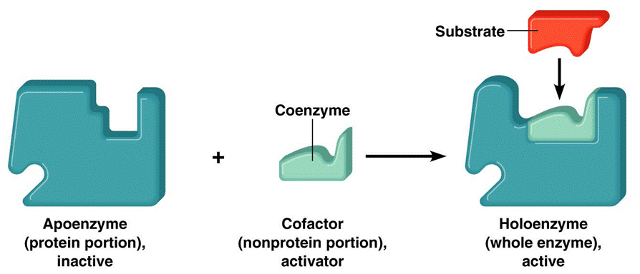

Cofactors are inorganic ions or organic non-protein molecules found at the active site of an enzyme that help the enzyme to function. If the cofactor is organic then it is called a coenzyme.

Many vitamins contain the cofactors and coenzymes that are required for enzymes to function.

